The Board of Directors of the Spanish Society for the Preservation of the Geological and Mining Heritage summons the III International Congress on Geological and Mining Heritage and the VII Scientific Session of the Society, inviting all those interested in the preservation and protection of the Geological, Mining and Metallurgical Heritage to participate.

DATES AND PLACE OF THE CELEBRATION
The sessions will take place on October 24th, 25th and 26h 2002 (Thursday, Friday and Saturday) at the Polytechnic University of Cartagena.

TOPICS
Papers will analyze aspects related with the preservation and management of the Geological, Mining and Metallurgical Heritage.

STRUCTURE OF SESSIONS
There will be four sessions. Each one of them will be opened by an invited report, followed by the communications presented by the different authors.
Reports and communications will be read during Thursday afternoon, Friday and Saturday morning, according to the following:

1. Geological Heritage
2. Heritage and Mining Landscape
3. Archaeology, History and Sociology of Mining
4. Museums, Geological and Mining Parks. Touristic projection

COMMUNICATIONS
All interested in presenting communications are invited to send their proposals to the Organizing Committee. Abstracts will have a maximum extension of a single-spaced DIN A-4 page and will be sent before September 20th 2002 in paper and diskette of 3,5 or CD (Word), or e-mail. Complete papers will have a maximum extension of 10 pages DIN A-4 and will be sent before the date of beginning of the Congress. In a later circular we will inform about the norms for their presentation.
Invited reports and communications that have been accepted by the Scientific Committee will be published in a Book of Records.

REGISTRATION
Registration fees include Congress documentation, the Book of Records, participation in all working sessions and in the included social acts in the program.
Registration fees are as follows:
SEDPGYM and APAI Members........30 Euros
Non Members......................................90 Euros
Students...............................................45 Euros
Inscription fees must have been paid before July 31st 2002. From this date on they will suffer an extra charge of 25%.
Payments will be made by means of check or bank transfer to: SEDPGYM
Account nº 2100-2879-03-0200234962
La Caixa
C/ Miguel Angel 33,28003 Madrid.

SPANISH SOCIETY FOR THE PRESERVATION OF THE GEOLOGICAL AND MINING HERITAGE

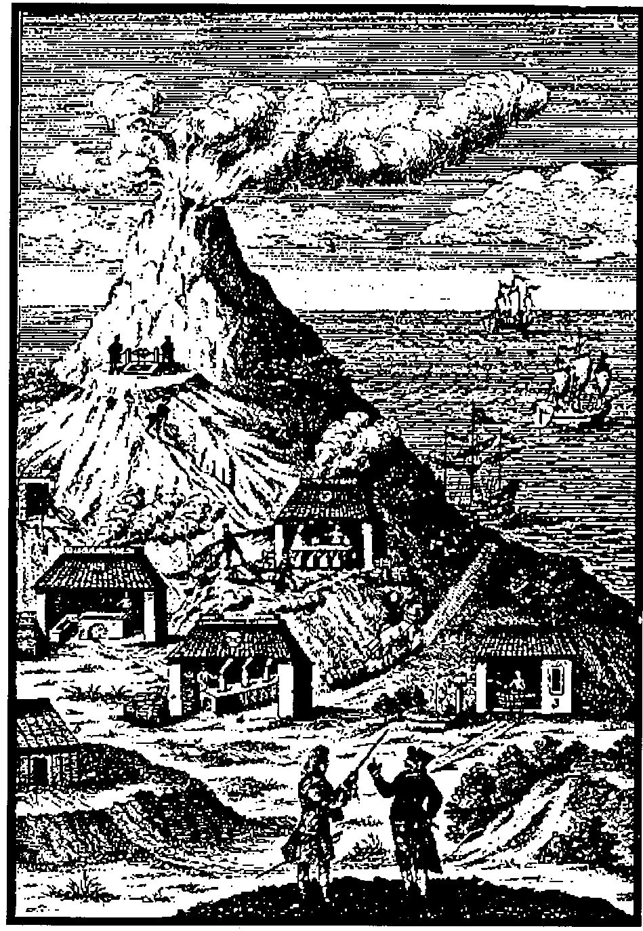

III INTERNATIONAL CONGRESS ON GEOLOGICAL AND MINING HERITAGE

HERITAGE PRESERVATION AND REGIONAL DEVELOPMENT

VII SCIENTIFIC SESSION

Cartagena October 24th, 25th and 26h 2002

COMITÉ DE HONOR

SPANISH SOCIETY FOR THE PRESERVATION OF THE GEOLOGICAL AND MINING HERITAGE

III INTERNATIONAL CONGRESS ON GEOLOGICAL AND MINING HERITAGE (PRE-(REGISTRATION TO RECEIVE FURTHER CIRCULARS)

Name and surname……………………………………………………………………….
Adress…………………………....…………..……………………………….
Postal Code…………..Town………...............……Country…………………………………….
Phone…………………Fax…………………..E.mail…………………………………
Do you intend to present a communication?…Yes………………………No………………
If you present a communication, on which topic?: 1…….. 2……….. 3…….….4……
Signature……………………………………………Date…………………………………

- COUNCIL FOR ENVIRONMENT C.A.R.M.
- COUNCIL FOR CULTURE C.A.R.M.
- COUNCIL FOR INDUSTRY C.A.R.M.
- CARTAGENA CITY COUNCIL
- LA UNIÓN CITY COUNCIL
- MAZARRÓN CITY COUNCIL
- GEOLOGICAL AND MINING INSTITUTE OF SPAIN
- RECTOR OF THE U.P.C.T.
- DEAN OF THE MINING ENGINEERS ASSOCIATION OF THE LEVANTE AREA
- DEAN OF THE TECHNICAL MINING ENGINEERS ASSOCIATION OF CARTAGENA
- THE OFFICIAL GEOLOGISTS' ASSOCIATION OF SPAIN

ORGANIZING COMMITTEE

PRESIDENT:

JOSÉ IGNACIO MANTECA MARTÍNEZ.

UPCT

SECRETARy:

CRISTÓBAL GARCÍA GARCÍA. UPCT

MEMBERS:

MANUEL ALCARÁZ APARICIO. UPCT
Mª CARMEN BERROCAL. UNED

ANGEL FAZ CANO. UPCT

ALEJANDRINO GALLEGO.UPCT

ANTONIO GARCÍA MARTÍN. UPCT

FRANCISCO GUILLÉN MONDEJAR. UMU

JUAN MIGUEL MARGALEF MARTÍNEZ. FSM

TOMÁS RODRÍGUEZ ESTRELLA.UPCT

EMILIO TRIGUEROS TORNERO. UPCT

SCIENTÍFIC COMMITTEE

PRESIDENT:

JOSÉP MARÍA MATA PERELLÓ. UPC

MEMBERS:

RAFAEL ARANA CASTILLO. UMU

FRANCISCO AYALA CARCEDO. IGME

DANIEL BARETINO FRAILE. IGME
J.MANUEL BRANDAO. IGM(Portugal)
ANTONIO DAZA SÁNCHEZ. UCO
CLAUDE DOMERGUE. U.Toulouse (FrancE).

JOSEP GIBERT CLOLS. CSIC/ Mu. Paleont. Sabadell

ALEXANDRE MACHADO LEITE U.Porto (Portugal)

J.IGNACIO MANTECA MARTÍNEZ UPCT

OCTAVIO PUCHE RIART. UPM
ISABEL RÁBANO. IGME

CORRESPONDENCE AND REGISTRATION

Mercedes Martínez Escudero
Depto. de Ingeniería Minera, Geológica y Cartográfica.
Universidad Politécnica de Cartagena
Pº Alfonso XIII,52.
30203 CARTAGENA(Murcia), Spain
e.mail: mercedes.escudero@dep.upct.es
Phone: 968 325489 Fax: 968 325435

ORGANIZING ENTITIES
Spanish society for the Preservation of the Geological and Mining Heritage
Polytechnic University of Cartagena (UPCT)
Geological and Mining Institute of Spain (IGME)

COLABORATING ENTITIES
Fundación Séneca
Council for Agriculture, Water and Environment
Council for Turisme
Council for Culture
Council for Industry
City Council of Cartagena
City Council of La Unión
City Council of Mazarrón
Banco Santander Central Hispano
Caja Murcia
Consejo Superior de Colegios de Ingenieros de Minas
Mining Engineers Association Of The Levante Area
Technical Mining Engineers Association Of Cartagena
Official Geologists' Association
AEPRU
Consorcio Turístico Cultural La Unión
Española del Zinc,S.A.
Unión Española de Explosivos S.A.
Inmogolf,S.A.
Portman Golf
Fundación Sierra Minera

ADDITIONAL INFORMATION
http://www.upct.es/sedpgym http://www.inicia.es/de/sedpgym

